Ideation Phase
Empathize & Discover
Date | 10 July 2026
Team ID | Geeta Rani
Project Name | ShopEZ
Maximum Marks | 4 Marks

Empathy Map Canvas
In the case of ShopEZ, an empathy map was developed considering online shoppers looking for a fast and reliable way to browse products, manage a cart, and complete a purchase. Shoppers usually face frustrations such as scattered product listings, unclear pricing across currencies, and complicated account creation. These users expect an easy yet secure way of browsing, adding items to a cart, and checking out. Considering this, ShopEZ came into being as a product that offers customers a clean product catalog, secure authentication, persistent cart management, and multi-currency pricing.

Empathy Map (Detailed Analysis)
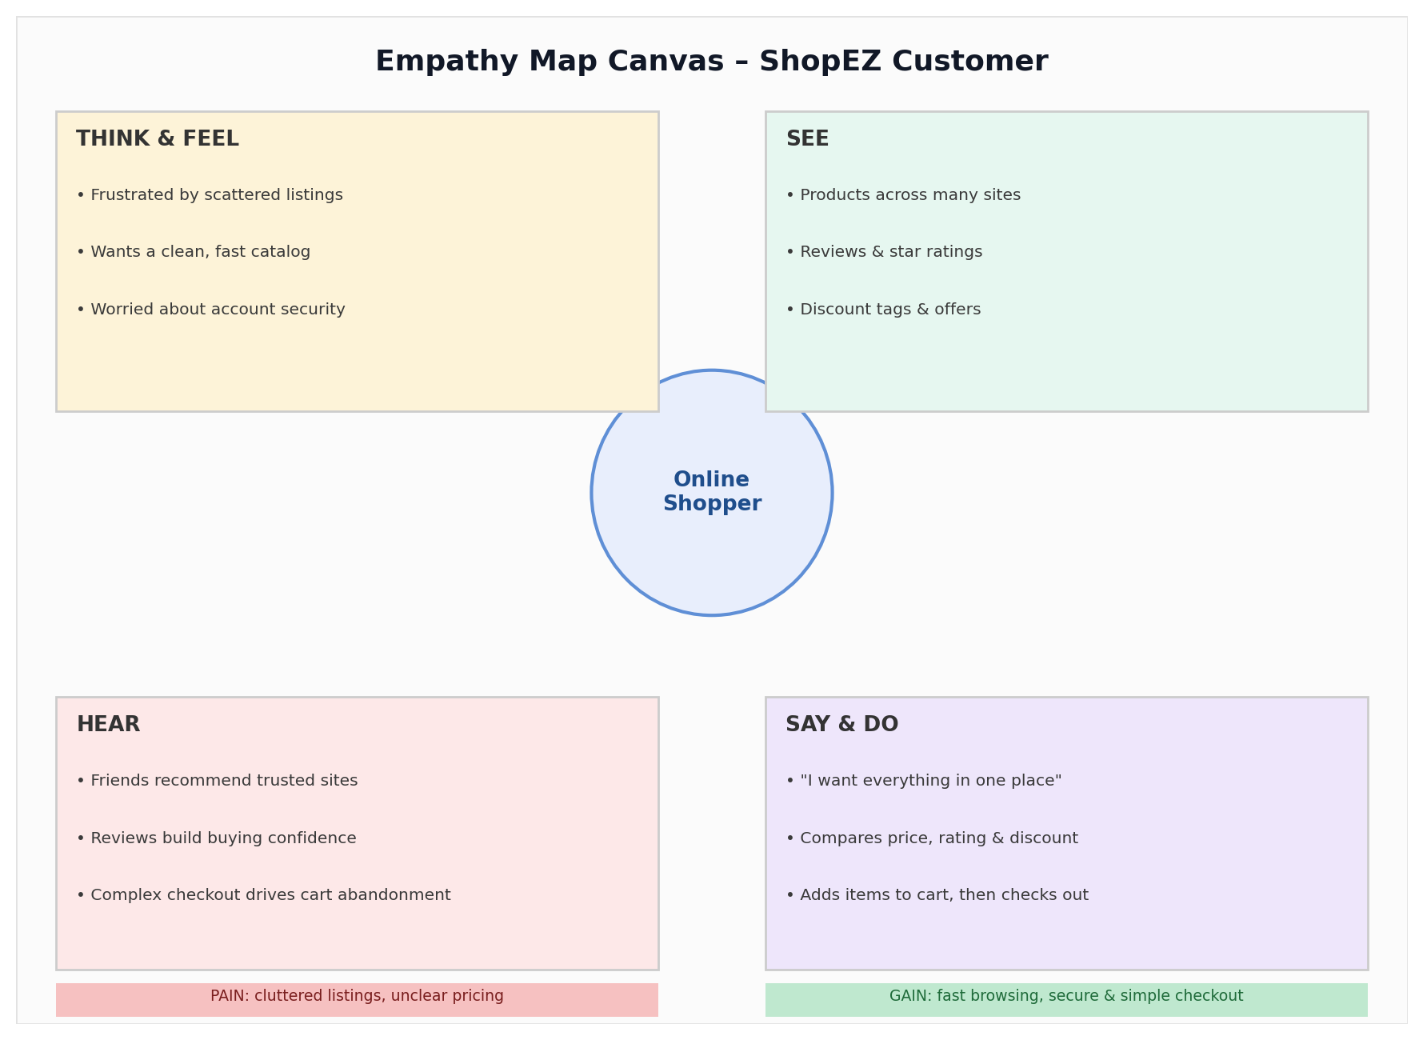

Who are empathizing with?
Person: An online shopper looking to browse and purchase everyday products.
Situation: Needs to quickly find products, compare prices, and complete a purchase without friction.
Role: A customer who browses the catalog, manages a cart, registers/logs in, and checks out on ShopEZ.

Goal
To find and purchase the right products quickly, at a clear price, without navigating a cluttered or slow interface.
To have confidence that their account and cart data are handled securely.

What do they THINK and FEEL?
PAINS (Fears, Frustrations, Anxieties)
- Frustrated by scattered product listings across multiple sites.
- Worried about account security while registering or logging in.
- Anxious about losing cart items between sessions.
- Confused by prices shown in an unfamiliar currency.

GAINS (Wants, Needs, Hopes, Dreams)
- Wants a fast, single-page product browsing experience.
- Hopes to see clear pricing, ratings, and discounts at a glance.
- Needs a simple, persistent shopping cart.
Wants secure access to their account and order history.

What do they HEAR?
Others say: Online shopping platforms save time compared to visiting physical stores.
Friends say: A clean cart and checkout flow builds trust in a shopping app.
Family members say: Always check ratings and reviews before buying online.
Second-hand: Many shoppers abandon carts when the checkout process feels complicated.

What do they SEE?
- Multiple products across categories such as Electronics, Fashion, Home, Sports, and Books.
- Other e-commerce platforms and marketplace websites.
- Product images, prices, discounts, ratings, and seller names.
- Reviews and star ratings from other buyers.

What do they SAY?
- I want to see all products in one place.
- I want to know exactly what I'm paying, in my own currency.
- Adding to cart and checking out should be quick.

What do they DO?
- Browse products by category and price.
- Compare ratings, discounts, and seller information.
- Add products to the cart and adjust quantities.
- Register or log in to save their session and view their profile.

What other thoughts influence their behavior?
- Higher star ratings and review counts increase confidence in a product.
- Visible discounts influence the decision to add an item to the cart.
- A secure login process builds trust in the platform.

What do they need to DO?
- Register and log in securely.
- Browse and select suitable products.
- Add products to the cart and manage quantities.
- View prices in their preferred currency.
- Complete checkout without unnecessary delays.

